**SMART AIR COOLER**

**Prajakta Zaavde(116A3064)**

**Sunetra Seshagiri(116A3061)**

**Shreya Patil(217A3074)**

**Chapter 1**

**Introduction**

IOT is a domain of technology which stands for internet of things that is used for connecting growing number of devices such as Internet TV’s, smart phones and sensors to the internet. It has become an essential factor when it comes to providing seamless communication and exchanging of data with connected devices. IOT provides means to control these factors from any remote location in the world.

Here IOT is used for communicating various sensors to the controller where the controller checks the status of sensors and takes it as an input for further processing. It is as well as used for remote monitoring of homes from anywhere in the globe or without an indoor presence. There are various existing systems that are used for Security purposes such as Bluetooth-based systems, Microcontrollers, Arduino boards etc. But they have some disadvantages like limited range, limited accessibility etc.

Wireless Sensor Networks (WSN) is a wireless network that consists of base stations and numbers of nodes (wireless sensors). These networks are used to monitor physical or environmental conditions like sound, pressure, temperature and co-operatively pass data through the network to a main location.

The development of wireless sensor networks was motivated by military applications such as battlefield surveillance; today such networks are used in many industrial and consumer applications, such as industrial process monitoring and control, machine health monitoring, and so on.

**Chapter 2**

**Review of Literature**

Marco Nesarajah, and Georg Frey et.al[1] presents a detailed comparison between Peltier elements (also called thermoelectric coolers (TEC)) and thermoelectric generators (TEG) for the usage as thermoelectric power generators. Whereas the former is normally known for cooling applications or heat pump uses, it can also be used as generator.

Zhao et al.[2] presented a temperature- and humidity-independent control strategy to reduce the energy consumption of an AC in an office building. The  previous  researches  of  applying  control  strategies  on  ACs  are  based  on  the  difference  of parameters and cause the reaction. This is one kind of passive responses and may not be suitable for human comfort.

Andreas Ihring et.al[3]thermoelectric planar thin-film microcoolers become more and more important due to their cooling and temperature stabilization ability, respectively, in MEMS devices. This paper reports on the investigation of the design, manufacturing, and characterization of a membrane-integrated thin-film thermoelectric cooling arrangement for active temperature control and precise local cooling of the sensitive region in a thin-film dew-point sensor. The sensor concept as explained by Ernst Kessler et.al[4] is based on the combination of a thermal sensor heater and a planar thinfilm Peltier cooler, which are all arranged on a freestanding and thermally insulated membrane. To obtain a high performance concerning the maximum temperature decrease of the activecooled membrane, a highly efficient thermoelectric materials combination of Sb and Bi0.87Sb0.13 was used for the fabrication of the in-plane Peltier configuration. For the first sensor setup, a temperature decrease of 10.6 K was achieved under atmospheric conditions at 293 K. In combination with an externally assembled two-stage Peltier cooler dew-point, temperature measurements down to 213 K (−60 °C) were performed in a climatic exposure test cabinet.

**Chapter 3**

**Review on present investigation**

**3.1 Smart Air Cooler**

Air Conditioner

* It collects hot air from a given space, processes it within itself with the help of a refrigerant and a bunch of coils and then releases cool air into the same space where the hot air had originally been collected.
* Your air conditioning unit uses chemicals that convert from gas to liquid and back again quickly.
* These chemicals transfer the heat from the air inside your property to the outside air. The AC unit has three key parts. These are the compressor, the condenser, and the evaporator.

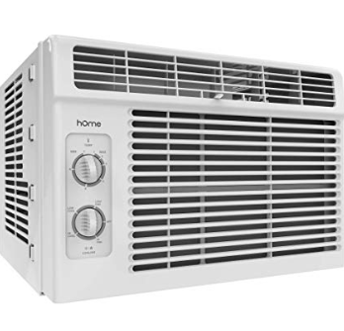

Major drawbacks are air conditioner uses lots of electricity and the installation and maintainance of a ducted air conditioning is very much expensive.

The present air-conditioning system produces cooling effect by refrigerators. Using these refrigerators can get maximum output but one of the major disadvantages is harmful gas emission and global warming. These problem can be overcome by using thermoelectric modules(Peltier effect) air-conditioner and there by protecting the environment.

Thermoelectric cooling systems have advantages over conventional cooling devices such as compact in size, light in weight, high reliability, no mechanical moving parts and no working fluid.

The proposed system uses peltier sensor to cool the water in the container.

The water level will be measured by water level depth sensor. And if it is less than a particular threshold then alarm will be set.

Once the water in the container is full, the hand pump will sprinkle the water over the cloth or mesh kept so the it get wet.

Ultrasonic sensor will sense the distance from which a person is coming and start the fan.

**Chapter 4**

**Study of various target boards**

**4.1 NodeMCU:**

**NodeMCU** is an open source [IoT](https://en.wikipedia.org/wiki/Internet_of_Things" \o "Internet of Things)platform. It includes [firmware](https://en.wikipedia.org/wiki/Firmware" \o "Firmware)which runs on the [ESP8266](https://en.wikipedia.org/wiki/ESP8266) [Wi-Fi](https://en.wikipedia.org/wiki/Wi-Fi)[SoC](https://en.wikipedia.org/wiki/System_on_a_chip) from [Espressif Systems](https://en.wikipedia.org/w/index.php?title=Espressif_Systems&action=edit&redlink=1" \o "Espressif Systems (page does not exist)), and hardware which is based on the ESP-12 module. The term "NodeMCU" by default refers to the firmware rather than the development kits. The firmware uses the [Lua](https://en.wikipedia.org/wiki/Lua_(programming_language)) scripting language. It is based on the eLua project, and built on the Espressif Non-OS SDK for ESP8266. It uses many open source projects, such as lua-cjson and [SPIFFS](https://en.wikipedia.org/w/index.php?title=SPIFFS&action=edit&redlink=1).

**Features or characteristics:**

Open-source, Interactive, Programmable, Low cost, Simple, Smart, WI-FI enabled

* **Arduino-like hardware IO**

Advanced API for hardware IO, which can dramatically reduce the redundant work for configuring and manipulating hardware. Code like arduino, but interactively in Lua script.

* **Nodejs style network API**

Event-driven API for network applicaitons, which faciliates developers writing code running on a 5mm*5mm sized MCU in Nodejs style. Greatly speed up your IOT application developing process.

* **Lowest cost WI-FI**

Less than $2 WI-FI MCU ESP8266 integrated and esay to prototyping development kit. We provide the best platform for IOT application development at the lowest cost.

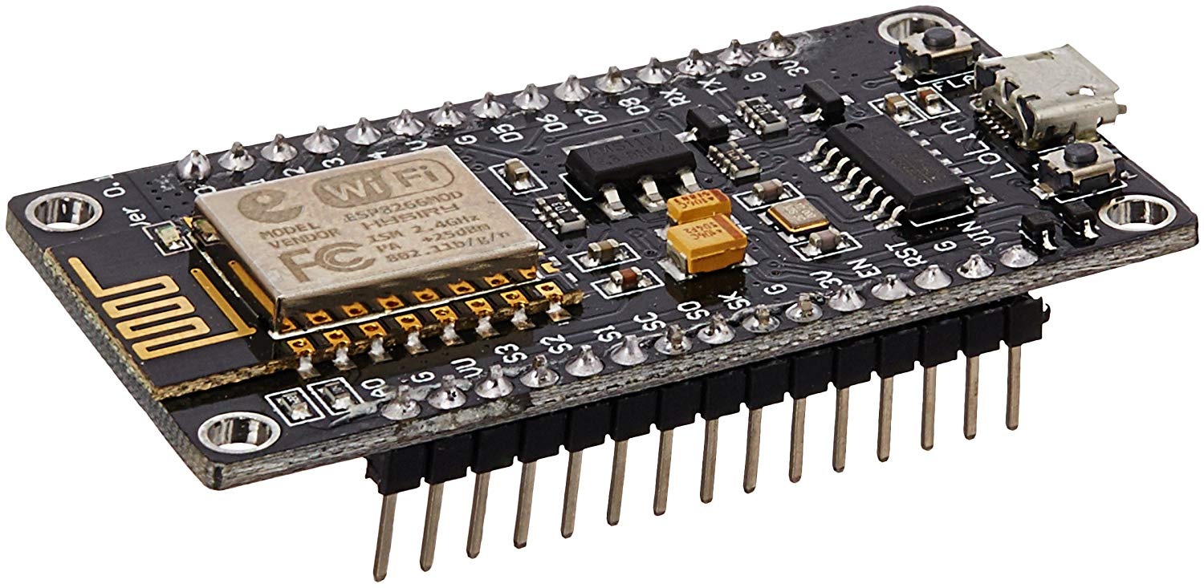

**Fig 4.1.1: NodeMCU**

**Chapter 5**

**Report on Proposed system and its implementation**

In this project, Water level sensor helps to indicate whether the tank is full or empty as water is important part of cooler. Peltier sensor plays a vital role of cooling the water. This sensor is properly compatible with the arduino circuit. Hand pump is used to raise the water to sprinkle over the material that will help to get cool air. Here we will be using cloth. Ultrasonic sensor detects the distance. Thus giving a threshold, if the user comes closer to cooler, then the fan attached to the DC motor will start to rotate.

**5.1. Components Required:**

**1. Ultrasonic Sensor:**

An **ultrasonic sensor** is an instrument that measures the distance to an object using ultrasonic sound waves.

An ultrasonic sensor uses a transducer to send and receive ultrasonic pulses that relay back information about an object’s proximity. High-frequency sound waves reflect from boundaries to produce distinct echo patterns Ultrasonic sound vibrates at a frequency above the range of human hearing.  Transducers are the microphones used to receive and send the ultrasonic sound. Our [ultrasonic sensors](https://www.maxbotix.com/SelectionGuide/Selection-Guide.htm), like many others, use a single transducer to send a pulse and to receive the echo.  The sensor determines the distance to a target by measuring time lapses between the sending and receiving of the ultrasonic pulse.

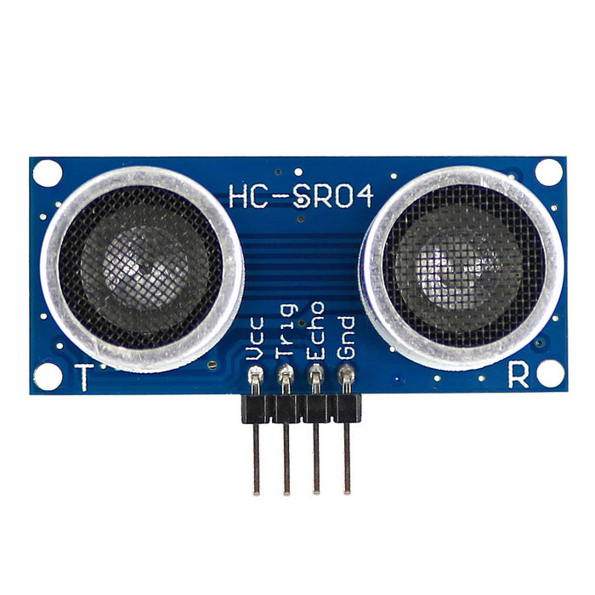

**Fig 1: Ultrasonic Sensor**

**2. Thermoelectric Peltier Sensor:**

**Thermoelectric cooling** uses the [Peltier effect](https://en.wikipedia.org/wiki/Peltier_effect) to create a [heat](https://en.wikipedia.org/wiki/Heat) flux between the junction of two different types of materials. A Peltier cooler, heater, or [thermoelectric](https://en.wikipedia.org/wiki/Thermoelectric) heat pump is a solid-state active [heat pump](https://en.wikipedia.org/wiki/Heat_pump) which transfers heat from one side of the device to the other, with consumption of [electrical energy](https://en.wikipedia.org/wiki/Electrical_energy), depending on the direction of the current. Such an instrument is also called a **Peltier device**, **Peltier heat pump**, **solid state refrigerator**, or **thermoelectric cooler** (**TEC**). It can be used either for heating or for cooling, although in practice the main application is cooling. It can also be used as a temperature controller that either heats or cools.

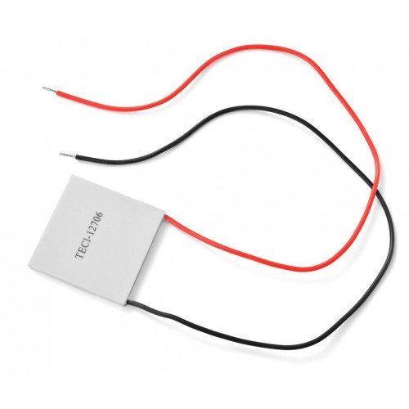

**Fig 2: Peltier Sensor**

**3. Float sensor:**

A **float switch** is a type of [level sensor](https://en.wikipedia.org/wiki/Level_sensor), a device used to detect the [level of liquid](https://en.wikipedia.org/wiki/Liquid_level) within a tank. The switch may be used to control a [pump](https://en.wikipedia.org/wiki/Pump), as an indicator, an alarm, or to control other devices. One type of float switch uses a [mercury switch](https://en.wikipedia.org/wiki/Mercury_switch) inside a hinged float. Another common type is a float that raises a rod to actuates a [microswitch](https://en.wikipedia.org/wiki/Micro_switch). One pattern uses a [reed switch](https://en.wikipedia.org/wiki/Reed_switch) mounted in a tube; a float, containing a magnet, surrounds the tube and is guided by it. When the float raises the magnet to the reed switch, it closes. Several reeds can be mounted in the tube for different level indications by one assembly. A very common application is in [sump pumps](https://en.wikipedia.org/wiki/Sump_pump) and [condensate pumps](https://en.wikipedia.org/wiki/Condensate_pump) where the switch detects the rising level of liquid in the sump or tank and energizes an electrical pump which then pumps liquid out until the level of the liquid has been substantially reduced, at which point the pump is switched off again. Float switches are often adjustable and can include substantial [hysteresis](https://en.wikipedia.org/wiki/Hysteresis). That is, the switch's "turn on" point may be much higher than the "shut off" point. This minimizes the on-off cycling of the associated pump.

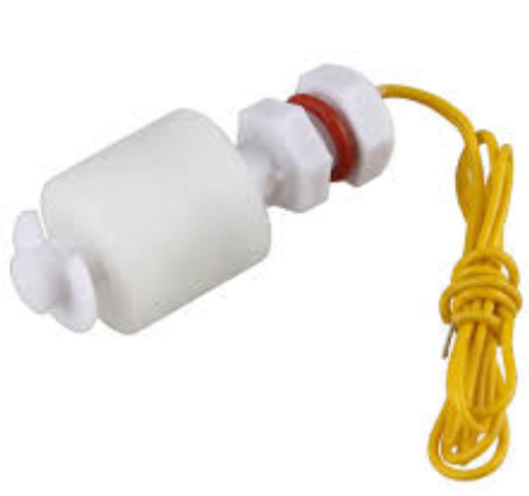

**4. Relay Module:**

The **relay module** is a separate hardware device used for remote device switching. With it you can remotely control devices over a network or the Internet. Devices can be remotely powered on or off with commands coming from ClockWatch Enterprise delivered over a local or wide area network. A **relay** is an electromagnetic switch operated by a relatively small electric current that **can** turn on or off a much larger electric current. The heart of a **relay** is an electromagnet (a coil of wire that becomes a temporary magnet when electricity flows through it). Different **Types** of **Relays**. Classification or the**types** of **relays** depend on the function for which they are used.

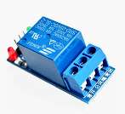

**5. Jumper wires:**

A jump wire is an electrical wire, or group of them in a cable, with a connector or pin at each end, which is normally used to interconnect the components of a breadboard or other prototype or test circuit, internally or with other equipment or components, without soldering. Individual jump wires are fitted by inserting their "end connectors" into the slots provided in a breadboard, the [header connector](https://en.wikipedia.org/wiki/Pin_header#Header_connector) of a circuit board, or a piece of test equipment.

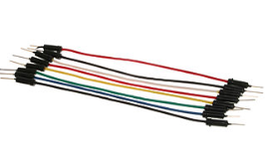

**5.2. Working Explanation:**

In this project, float sensor helps to indicate whether the tank is full or empty as water is important part of cooler. Peltier sensor plays a vital role of cooling the water. This sensor is properly compatible with the nodeMCU circuit. When power is provided to it, one side of the sensor becomes cold while one side becomes hot. We will connect the cold side to our model. The water pump is used to raise the water to sprinkle over the material that will help to get cool air. Here we will be using cloth. Ultrasonic sensor detects the distance. It will be connected in the front side of our model. So, whenever the person comes near to the fan it will start. That means, giving a threshold, if the user comes closer to cooler, then the fan will start to rotate. Similarly, for the water tank as well a threshold value will be mentioned. Once water goes lower than that value, an alert message will be sent to the user.

All the data collected from the sensors will be uploaded to the cloud. We have provided wifi connectivity to our prototype. The values are stored on a cloud database called “ubidots”. The user will be able to access the data.

**5.3. Circuit Diagram:**

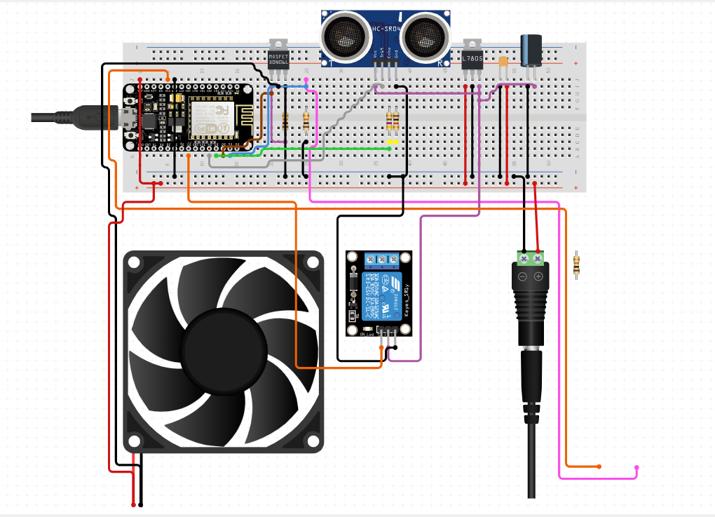

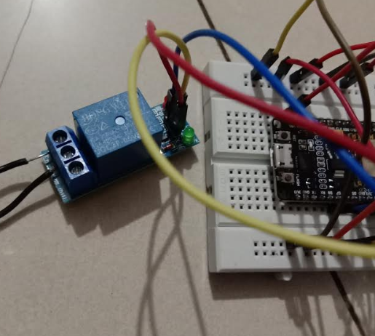

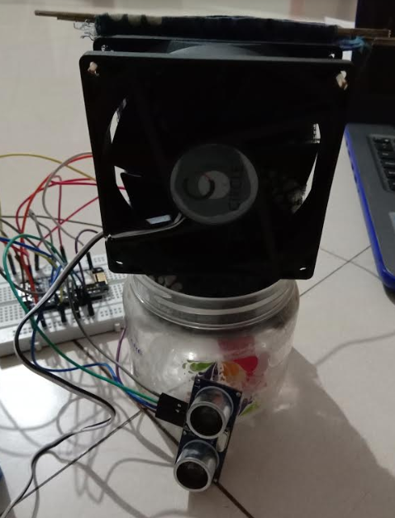

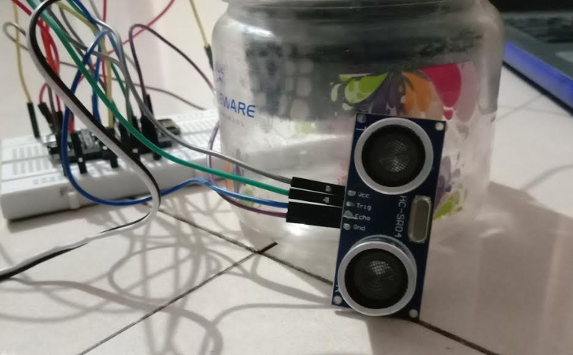

**Chapter 6**

**6.1 Code**

#include "UbidotsMicroESP8266.h"

#define TOKEN "BBFF-MiE0oUk21heNCN8QJesAvsp9M5KjO8" // Put here your Ubidots TOKEN

#define WIFISSID "prajakta" // Put here your Wi-Fi SSID

#define PASSWORD "prajakta99" // Put here your Wi-Fi password

Ubidots client(TOKEN);

#define Sensor A0

// defines pins numbers

const int relay = 13;

const int trigPin = 2; //D4

const int echoPin = 0; //D3

// defines variables

long duration;

int distance;

void setup() {

// Setup a function to be called every second

pinMode(trigPin, OUTPUT); // Sets the trigPin as an Output

pinMode(relay, OUTPUT);

pinMode(relay,HIGH);

pinMode(echoPin, INPUT); // Sets the echoPin as an Input

Serial.begin(9600); // Starts the serial communication

client.wifiConnection(WIFISSID, PASSWORD);

}

void loop() {

// Clears the trigPin

digitalWrite(trigPin, LOW);

delayMicroseconds(2);

// Sets the trigPin on HIGH state for 10 micro seconds

digitalWrite(trigPin, HIGH);

delayMicroseconds(10);

digitalWrite(trigPin, LOW);

// Reads the echoPin, returns the sound wave travel time in microseconds

duration = pulseIn(echoPin, HIGH);

// Calculating the distance

distance= duration*0.034/2;

// Prints the distance on the Serial Monitor

Serial.print("Distance: ");

Serial.println(distance);

if(distance>500)

{

pinMode(relay, LOW);

}

else{

pinMode(relay,HIGH);

}

int val = digitalRead(A0); // read input value

Serial.println(val);

client.add("Level", val);

client.sendAll(true);

if (val<100){

Serial.println(“refill water”);

}

delay(2000);

}

**6.2 Programming Explanation:**

We have connected the input pin of relay module to the D0 pin of nodeMCU. The one pin of fan to COM while the other NOC pin goes to battery’s negative. The positive of battery is connected to Vin. The ultrasonic sensor and float sensor is connected as shown in the circuit diagram.

According to the code first we are installing the library of ‘ubidots’ and then entering the token received in the code. Then we provide the ‘username’ and ‘password’ to the system to connect wifi to our model. In the setup part we add all the pinModes of the sensor i.e. we have kept level sensor and ultrasonic sensor as INPUT while the relay module which is connected to the fan is kept as OUTPUT. We are sending the readings of ultrasonic sensor and level sensor to the cloud. Also we check if the water level is less than 100 then we send a message to fill water in the tank again. Also we check if the distance is less than 200 then the relay output goes high and the fan starts. Else the fan remains off.

**Chapter 7**

**Results and Discussion:**

**Data uploaded to cloud:**

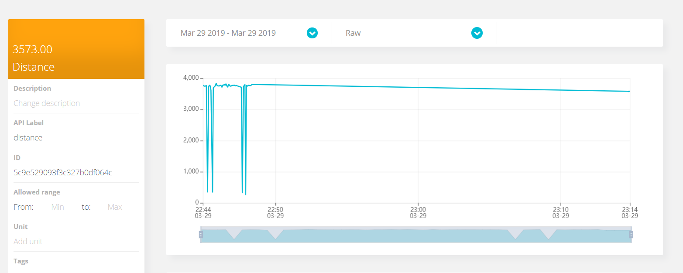

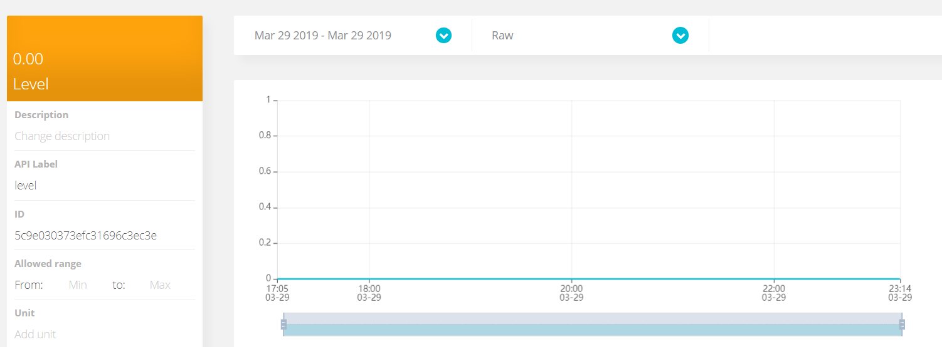

Whenever the distance is less than 200 the fan starts else it is off.

**Chapter 8:**

**Conclusion:**

The development of wireless sensor networks was motivated by military applications such as battlefield surveillance; today such networks are used in many industrial and consumer applications, such as industrial process monitoring and control, machine health monitoring, and so on. In our project we have efficiently made use of ultrasonic, float and pelteir sensor to capture data. We can store the data received from these sensors and view it as per requirement. Also the fan operates only when the user comes close to it, else it remains off.

# REFERENCES:

# [1]M D Kamrul Russel, “A Hybrid Thermoelectric Cooler Thermal Management System For Electronic Packaging,” Master of Applied Science Thesis, McMaster University, Ontario, Canada, 2011.

# [2] S. Kumar, A. Gupta, G. Yadav and H. P. Singh, "Peltier module for refrigeration and heating using embedded system," 2015 International Conference on Recent Developments in Control, Automation and Power Engineering (RDCAPE), Noida, 2015.

# [3] M. D. Thakor, S. K. Hadia and A. Kumar, "Precise temperature control through Thermoelectric Cooler with PID controller," 2015 International Conference on Communications and Signal Processing (ICCSP), Melmaruvathur, 2015.

# [4] A. Ihring, E. Kessler, U. Dillner, U. Schinkel, M. Kunze and S. Billat, "A Planar Thin-Film Peltier Cooler for the Thermal Management of a Dew-Point Sensor System," in Journal of Microelectromechanical Systems, vol. 24, no. 4, pp. 990-996, Aug. 2015.

# [5] Kumar, Saket & Ashutosh, Gupta. (2015). Peltier module for refrigeration and heating using embedded system. 10.1109/RDCAPE.2015.7281416.